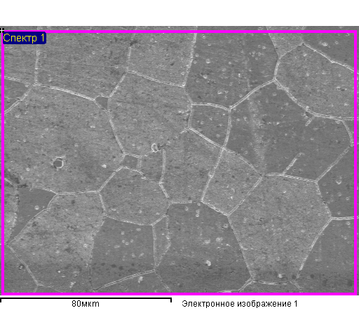

Average composition of indexed area

|  |  |  |  |  |  |
| --- | --- | --- | --- | --- | --- |
| Element | Mass. % | Atomic% | Element | Mass. % | Atomic% |
|  |  |  |  |  |  |
| C K | 4.48 | 17.75 | C K | 2.34 | 9.92 |
| Ti K | 5.66 | 5.63 | Ti K | 6.24 | 6.64 |
| Fe L | 89.86 | 76.62 | Fe L | 91.42 | 83.44 |
|  |  |  |  |  |  |
| Total | 100.00 |  | Total | 100.00 |  |

Structure element 1

|  |  |  |  |  |
| --- | --- | --- | --- | --- |
| Element | Mass. % | Atomic% | Mass. % | Atomic% |
| C K | 4.57 | 18.05 | 3.87 | 15.61 |
| Ti K | 6.51 | 6.44 | 6.29 | 6.36 |
| Fe L | 88.92 | 75.51 | 89.85 | 78.03 |
| Total | 100.00 |  | 100.00 |  |

Structure element 2 Structure element 3

|  |  |  |  |  |  |  |
| --- | --- | --- | --- | --- | --- | --- |
| Element | Mass. % | Atomic% |  | Element | Mass. % | Atomic% |
| C K | 3.61 | 14.74 |  | O K | 33.79 | 60.64 |
| Ti K | 4.42 | 4.53 |  | Ti K | 62.55 | 37.48 |
| Fe L | 91.97 | 80.74 |  | Fe L | 3.66 | 1.88 |
| Total | 100.00 |  |  | Total | 100.00 |  |

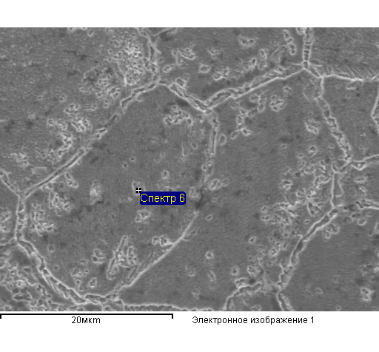

Structure element 4 Average composition of the area

|  |  |  |  |  |  |  |
| --- | --- | --- | --- | --- | --- | --- |
| Element | Mass. % | Atomic% |  | Element | Mass. % | Atomic% |
| N K | 5.92 | 14.89 |  |  |  |  |
| O K | 13.02 | 28.68 |  | C K | 2.75 | 11.50 |
| Ti K | 50.56 | 37.19 |  | Ti K | 7.17 | 7.52 |
| Fe L | 30.49 | 19.24 |  | Fe L | 90.08 | 80.99 |
| Total | 100.00 |  |  |  |  |  |
|  |  |  |  | Total | 100.00 |  |

Structure element 5

|  |  |  |
| --- | --- | --- |
| Element | Mass. % | Atomic% |
|  |  |  |
| C K | 1.52 | 6.64 |
| Ti K | 5.80 | 6.35 |
| Fe L | 92.68 | 87.01 |
|  |  |  |
| Total | 100.00 |  |

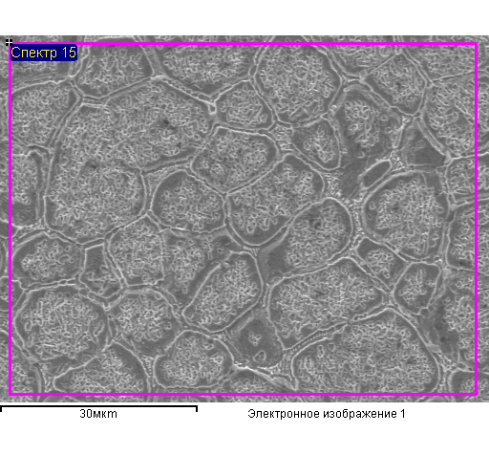

Average composition of the indexed area

|  |  |  |
| --- | --- | --- |
| Element | Mass. % | Atomic% |
| C K | 2.79 | 11.12 |
| O K | 2.20 | 6.58 |
| Ti K | 6.11 | 6.11 |
| Fe L | 88.90 | 76.20 |
| Total | 100.00 |  |

Structure element 6 Structure element 7

|  |  |  |  |  |  |  |
| --- | --- | --- | --- | --- | --- | --- |
| Element | Mass. % | Atomic% |  | Element | Mass. % | Atomic% |
| Ti K | 4.76 | 5.51 |  | Ti K | 3.57 | 4.14 |
| Fe L | 95.24 | 94.49 |  | Fe L | 96.43 | 95.86 |
| Total | 100.00 |  |  | Total | 100.00 |  |

Structure element 8

|  |  |  |
| --- | --- | --- |
| Element | Mass. % | Atomic% |
| Ti K | 50.97 | 54.79 |
| Fe L | 49.03 | 45.21 |
| Total | 100.00 |  |